- If no further Techno commercial Offer is to be cleared the Buyer will Click on the Button shown.
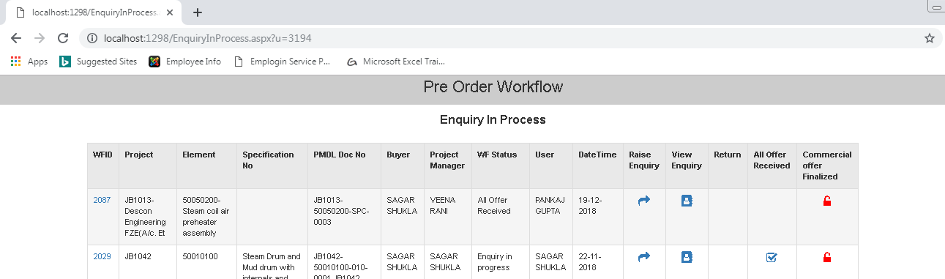
Click Here
91)

- On clicking here this record will disappear from this session.
